Data Analytics (DA)

Module-End -3

Module End Assignment:

“Analyzing E-Learning Platform Purchases using MySQL”

An eLearning database was created with 3 tables learners, courses and purchase. The following dataset was used
The following 3 tables were created and data was inserted:
Table 1: Learners (5 rows)
- Asha R – India
- Ravi Kumar – India
- Maya Nayir – UK
- Ramesh Tilak – USA
- Ganesh Kumar – Canada
Table 2: Courses (5 rows)
Course IDs 1–5 with prices:
- SQL (₹1999)
- Excel (₹3499)
- ML Basics (₹4999)
- Python (₹7999)
- AI Analytics (₹2999)
Table 3: Purchases (8 rows)
Across Jan–Mar 2025.

Viewing the table
Table 1:learners
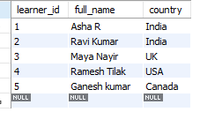
Table 2: courses

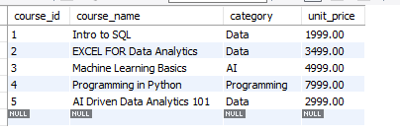
Table 3: purchases
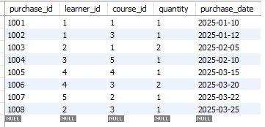

I Data Exploration Using Joins as per data presentation guidelines

Inner join to find Only learners who purchased something

OUTPUT

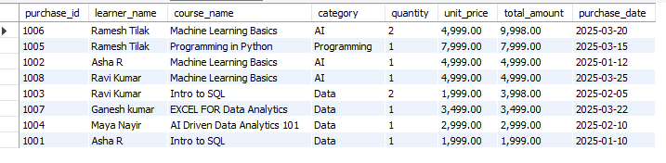
LEFT JOIN to Show ALL learners and their purchase details
OUTPUT

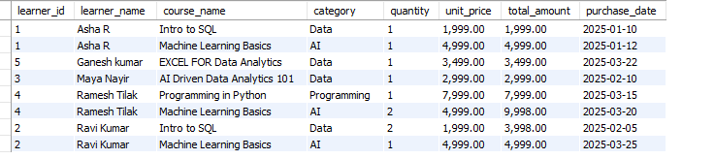
RIGHT and LEFT JOIN to Show ALL courses and any learners who purchased
OUTPUT
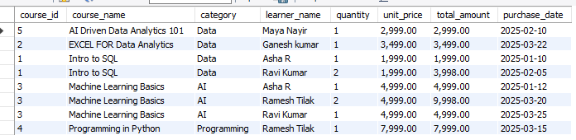

II Analytical Queries
Q1. Display each learner’s total spending (quantity × unit_price) along with their country.
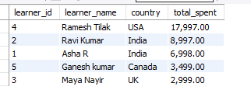
Q2. Find the top 3 most purchased courses based on total quantity sold.
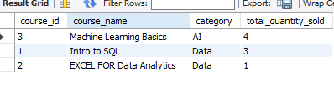
Q3. Show each course category’s total revenue and the number of unique learners who purchased from that category.
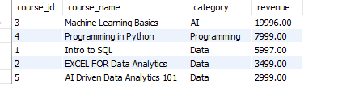
Q4. List all learners who have purchased courses from more than one category.
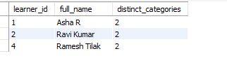

Q5. Identify courses that have not been purchased at all.
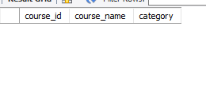
Additional query to view the entire dashboard Mini-Insights
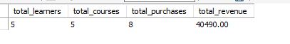

Key Insights
1. Machine Learning Basics is the top-performing course
- Course ID 3 generated ₹19,996 in revenue → almost 50% of total earnings.
- Highest number of units sold (4 units).
2. AI category contributes the highest revenue
- Combined AI category revenue = ₹22,995, the strongest among all categories.
- Indicates strong learner interest in advanced technical courses.
3. Learner 4 (Ramesh Tilak) is the top spender
- Total spending = ₹17,997, the highest among all learners.
- Shows high engagement and potential for further upselling.
4. March 2025 shows the highest purchase activity
- 4 purchases in March → peak month for learner enrollment.
- Early-year months (Jan–Mar) overall show strong demand.

5. All courses received at least one purchase
- No “dead inventory” — every course is contributing revenue.
- Indicates a balanced course catalogue with healthy learner interest.

Recommendations
1. Invest more in AI & ML course marketing
- These courses bring the highest revenue.
- Promote with paid ads, email campaigns, and upskilling offers.
2. Create bundle offers for beginners
Recommended bundle:
- Intro to SQL → Excel for Data Analytics → Machine Learning Basics
This will increase course progression and total revenue per learner.
3. Target high-value learners with loyalty benefits
- Provide early-access, discount coupons, or personalized course suggestions to learners like Ramesh Tilak, who show premium buying behaviour.
4. Launch promotions during February–March
- Purchase trends peak in these months → high conversion probability.
- Offer seasonal discounts or new course releases.
5. Improve visibility for mid-performing courses
- Courses like Excel and AI Analytics have moderate revenue.
- Promote through short reels, free modules, or LinkedIn posts.
6. Encourage repeat purchases
- Send reminders, upsell advanced courses, and offer completion certificates to motivate further enrolment.

